Deep Learning Based Stock Price Prediction Using LSTM, GRU, BiLSTM and BiGRU with Big Data Preprocessing

Afshan Mehmood
CCT College Dublin
2025102@student.cct.ie

Abstract—This Stock prices are highly dynamic and non-linear, making accurate prediction a significant challenge in financial markets. With numerous applications in investment, risk management, and portfolio optimization, stock price forecasting is crucial for investors and traders alike. Traditional statistical methods often fail to capture the complex patterns and dynamics inherent in stock prices. Therefore, this paper aims to develop a scalable and accurate framework for time series prediction of financial data, addressing the challenge of modeling complex temporal dependencies. The proposed framework integrates big data preprocessing with deep learning-based predictive modeling. In the first phase, stock price data of Apple Inc. (AAPL) was preprocessed using Hadoop Distributed File System (HDFS) and Apache Spark (PySpark) to enable scalable and efficient data handling. In the next phase, the preprocessed data was used to train four recurrent neural network architectures—LSTM, GRU, BiLSTM, and BiGRU. Models were trained in PyTorch, with hyperparameter tuning and validation-based training, and their performance was evaluated using Root Mean Squared Error (RMSE), Mean Absolute Error (MAE), and R² metrics. Comparative analysis revealed that all models successfully captured temporal patterns, with bidirectional architectures (BiLSTM and BiGRU) outperforming unidirectional models by leveraging both past and future temporal dependencies. The BiGRU model achieved the highest accuracy, making it a promising tool for stock price prediction. These results indicate that integrating distributed big data preprocessing with deep learning can significantly enhance predictive accuracy, offering valuable insights for investors and analysts seeking data-driven decision-making tools.
Keywords—Stock price prediction, LSTM, GRU, Bidirectional RNN, PySpark, Big data

Introduction
With the development of the global economy, the stock market has assumed vital importance and is regarded as a barometer of economic growth. Accurately forecasting stock prices can help governments in shaping macroeconomic management policies, assist enterprises in financial planning, reduce investment risks, and maximize returns. However, stock prices are highly volatile, nonlinear, and nonstationary, making accurate prediction extremely challenging.
Numerous researchers have proposed various methods to predict stock prices, among which econometric statistical models and machine learning approaches are the two main categories. Traditional statistical methods include Autoregression (AR), Moving Average (MA), Autoregressive Moving Average (ARMA), Autoregressive Integrated Moving Average (ARIMA) [1] and Linear Regression. Although these methods have achieved reasonable predictive performance, their assumption of linearity limits their ability to capture the complex, dynamic behavior of financial time series. To overcome these limitations, machine learning techniques such as Support Vector Regression (SVR) and Random Forests (RF) [2] have been proposed. Nevertheless, these models also struggle to capture long-term temporal dependencies inherent in stock price data.
Recent advancements in deep learning have shown significant promise for sequential modeling tasks. For time series prediction, Recurrent Neural Networks (RNNs) have demonstrated good performance; however, vanilla RNNs suffer from the vanishing gradient problem. To address this issue, Long Short-Term Memory (LSTM) and Gated Recurrent Unit (GRU) networks—variants of the standard RNN—were introduced to effectively learn long-term dependencies and sequential patterns. Yet, standard LSTM and GRU architectures are unidirectional, using only past information to predict future context. In real-world stock markets, patterns often depend on both past and upcoming information such as monthly cycles, reversals, or reactions to anticipated announcements. Bidirectional RNNs (BiRNNs) address this limitation by learning from both past and future contexts. These models consist of two recurrent layers that process input sequences in forward and backward directions, thereby capturing richer temporal dependencies and cyclic behaviors commonly observed in financial time series.
Although bidirectional models entail higher computational costs and longer training times, studies suggest that BiLSTM and BiGRU often achieve superior prediction accuracy compared to their unidirectional counterparts. However, existing studies primarily rely on single-machine processing pipelines, which limits their scalability when applied to large-scale financial datasets. The comparative predictive performance of these models in distributed big data environments—where preprocessing and model training are decoupled across systems—remains relatively unexplored. Most studies employ LSTM, GRU, or BiLSTM individually on small datasets without addressing the challenges of scalable preprocessing and efficient data management. Furthermore, only a few works integrate big data frameworks such as Hadoop and Spark with deep learning models to enhance scalability and computational efficiency in financial forecasting.
To address these gaps, this study proposes an integrated Hadoop–PySpark–PyTorch framework for stock price prediction. The daily stock price data of Apple Inc. (AAPL) was obtained from Yahoo Finance [3] using the yfinance Python library (Yahoo Finance, 2025), covering the period from 2021 to 2024. The data is stored in the Hadoop Distributed File System (HDFS) and preprocessed using Apache Spark (PySpark) to enable distributed and scalable data handling. The preprocessed data is then used to train four RNN-based architectures: GRU, LSTM, BiGRU, and BiLSTM. These models are implemented in PyTorch to predict stock prices, and their performance is evaluated using Root Mean Squared Error (RMSE), Mean Absolute Error (MAE), and R² metrics. To provide a comprehensive comparative analysis, the numerical results are supported by visualizations such as trend plots and error comparisons.
The main contributions of this paper can be summarized as follows:
- To develop a distributed preprocessing framework integrating [4] Hadoop (Apache Software Foundation, 2025) and [5] PySpark (StoryWord, 2023) for efficient handling of financial time series data.
- To evaluate the performance of four RNN-based architectures—LSTM, GRU, BiLSTM, and BiGRU—to identify the most suitable model for stock price prediction in a big data context.
The remainder of this paper is organized as follows: Section II provides a literature review on machine learning and deep learning models for stock price forecasting, along with recent advances in big data technologies like HDFS and Apache Spark (PySpark). Section III presents the proposed methodology, including data acquisition, preprocessing, and model architectures. Section IV discusses experimental results and model comparisons. Finally, Section V concludes the paper and outlines directions for future research.

LITERATURE REVIEW
Stock market analysis is vital to investment and financial decisions and various researchers have proposed different methods to predict stock prices. Stock market analysis is divided into three parts: Fundamental analysis, Technical analysis and Time series forecasting.
Time series forecasting is an analysis of time series data using linear/non-linear models, providing quantitative insights into patterns and volatility within sequential market data. The linear models such as Auto Regressive Moving Average (ARMA), Auto Regressive Integrated Moving Average (ARIMA) and Auto Regressive (AR) rely on predefined statistical relationships while non-linear approaches such as GARCH and neural networks; allow for more dynamic pattern recognition within sequential market data.

Using a linear modeling framework, Tang (2021) [6] applied the ARMA model to Apple Inc.’s adjusted closing prices (2018–2019). The high accuracy results confirm the model’s effectiveness for short-term linear prediction, after differencing for stationarity. Similarly, Sharma et al. (2024) [7] compared ARMA, LSTM, and GARCH models for leading technology firms, concluding that while linear models are computationally simple and efficient, they struggle to capture non-linear or abrupt market changes. This limitation of linearity and stationarity motivates a shift towards neural network-based methods, which are self-adjusting in nature and can adaptively model complex data patterns.

To demonstrate the effectiveness of neural networks, Kareem et al. (2021) [8] evaluated the performance of Artificial Neural Networks (ANN) and Convolutional Neural Networks (CNN) for weather forecasting. The study shows that while ANN models perform well on non-linear data, CNNs are particularly effective in capturing spatio-temporal dependencies from large datasets - akin to financial time series, making such approaches promising for stock price prediction. Expanding on deep learning applications, Reddy et al. (2022) [9] evaluated vanilla RNN and LSTM on Indian stock data, achieving Mean Absolute Percentage Errors (MAPE) values between 3% and 6%. Similarly, Liu (2022) [10] compared LSTM and GRU on China National Petroleum Corporation (CNPC) stock data, reporting nearly identical predictive accuracy and improved performance over RNN. This is because LSTM and GRU have better gradient control through the use of gates to control the flow of information.
Continuing the exploration of advanced deep learning models, Rathna et al. (2025) [11] compared the effectiveness of RNN, LSTM, and GRU architectures for forecasting multiple Indian stock market indices, incorporating moving averages, sentiment indicators, and hysteresis analysis in their framework. After evaluating models using metrics such as MSE, RMSE and R-squared, their results highlight GRU’s superior predictive accuracy and computational efficiency. Building on this, a subsequent study combined RNN, LSTM, GRU, and Prophet models for Google stock forecasting, finding GRU to be most effective overall and advocating ensemble approaches that integrate multiple deep learning architectures for enhancing predictive performance.
Hybrid and ensemble modeling has been further explored by [12] Sharma et al. (2025) and [13] Tripathy et al. (2023), who implemented LSTM and GRU hybrid architecture for the S&P BSE SME IPO and Nike stock datasets, respectively. Both models achieved exceptional performance highlighting the advantages of hybrid models for improved financial time series prediction.
Qi et al. (2023) expanded this perspective by introducing a GRU-based framework [14] augmented with Complete Ensemble Empirical Mode Decomposition with Adaptive Noise (CEEMDAN) - integrating wavelet denoising to mitigate high-frequency noise, which outperforms ARIMA and standard RNNs for the CSI300 and S&P 500 indices in terms of predictive accuracy. Although their BiLSTM–CNN hybrid performed less effectively, it drew attention to the potential of bidirectional models for processing sequential dependencies.
Advancing the exploration of bidirectional architectures, Hemajothi et al. (2024) proposed a BiLSTM–GRU model [15] that combines BiLSTM’s bidirectional temporal learning with GRU’s computational efficiency, achieving 92% accuracy and outperforming CNN and ANN baselines. Exploring bidirectional models, Shaikh and Ramadass (2024) [16] conducted an extensive evaluation of LSTM, BiLSTM, GRU, BiGRU and RNN across National Stock Exchange of India (NSEI) datasets in multiple sectors, revealing BiGRU and BiLSTM as the best performers whereas RNN consistently underperformed. Similarly, Kumari et al. (2024) examined unidirectional and bidirectional RNNs [17] for Google stock prediction, finding LSTM to outperform the rest with 98.57% accuracy, indicating that higher architectural complexity does not always ensure improved results. Moreover, it highlights a gap in the literature: there remains a need for methodical evaluation of how these architectures perform, especially when scaled with large financial datasets.
Addressing this research gap, our work narrows the focus to a targeted comparative analysis of LSTM, BiLSTM, GRU, and BiGRU models for stock price prediction by integrating big data processing frameworks, such as Hadoop and PySpark with deep learning models. This is done to enhance scalability and computational efficiency when handling large-scale financial data, thus bridging the gap between deep learning performance and data-intensive processing requirements.
The idea of the integration of big data technologies is supported by a growing body of research. Big data technologies like Hadoop and Apache Spark offer distributed storage and parallel computing capabilities, thus empowering deep learning models to train efficiently on high-frequency stock market data. In this context, Inoubli et al. (2018) developed a comprehensive survey [18] and experimental comparison of popular big data frameworks, including Hadoop, Spark, Flink, Samza, and Storm. Their study identifies that Spark demonstrates superior processing speed due to its in-memory computation capability, while Hadoop shows robustness in large cluster management. Extending this, Liu (2024) explored how Apache Spark can be used for real-time stock market analysis [19]. The study introduces two key methodologies — Nowcasting financial time series using streaming data and sentiment analysis with machine learning — to improve forecasting accuracy and scalability via Spark’s RDD and HDFS architecture.
Working on a similar approach, Indirman et al. (2023) examined the efficiency of distributed ML computation using Hadoop and Spark [20] across Bitcoin, gold, and housing price datasets. Their results indicate scaling efficiency but followed by higher computational demands for deep learning models like LSTM. Likewise, Sharma et al. (2024) also emphasized the importance of the Hadoop ecosystem, Cloudera, and PySpark for scalable and parallel data processing and management of massive, heterogeneous stock market data [21].
Collectively, these studies form the empirical and technological foundation for our present research, which aims to integrate Hadoop and PySpark with advanced deep learning architectures (LSTM, BiLSTM, GRU, BiGRU) for real-world high-frequency stock price prediction.

PrOPOSED METHODOLOGY
In order to predict stock prices, the proposed framework involves employing big data technologies like Hadoop and Pyspark for preprocessing and dynamic deep learning models like LSTM, GRU, BiLSTM and BiGRU for training and evaluation. Before detailing the workflow, the key tools and technologies used in this study are summarized below:

Background of Tools and Technologies
In this sub-section, we will be discussing about the technologies used in our work.

Hadoop: Hadoop: Hadoop is an open-source software framework for distributed storage and processing of very large datasets on clusters built from commodity hardware. It was founded by Doug Cutting at Yahoo and Mike Cafarella at the University of Michigan in 2008. Hadoop consists of two main components: Hadoop MapReduce, which manages parallel processing of large datasets, and Hadoop Distributed File System (HDFS), which handles data storage. HDFS is a distributed storage system designed to manage data across clusters in a scalable and fault-tolerant manner. Its abstract architecture and components are shown in Figure 1. HDFS employs a master/slave structure, with a NameNode acting as the master and multiple DataNodes as slaves. DataNodes are responsible for storing and retrieving data blocks, while NameNode manages the file system namespace and metadata. To ensure reliability and high availability, data is split into blocks and replicated across DataNodes. The state of the NameNode is periodically saved by a backup node called the Secondary NameNode, which assists in case of a failure.

Apache Spark: Apache Spark is an open-source, distributed computing framework designed for large-scale data processing. It was originally developed at the University of California, Berkeley, in 2009. Spark offers several advantages over other Big Data frameworks such as Hadoop and Storm. Unlike standard MapReduce in Hadoop, which relies on disk-based storage between jobs, Spark enables in-memory processing thus allowing rapid, concurrent, and fault-tolerant computation. Moreover, Spark supports iterative and real-time processing, while MapReduce is primarily designed for batch workloads.

Spark provides high-level libraries for various data processing tasks, such as machine learning (MLlib), SQL queries (SparkSQL), stream processing (Spark Streaming), and graph analytics (GraphX). PySpark is a Python API for Spark which is responsible for enabling efficient preprocessing and analysis of large datasets.

At the core of Spark are Resilient Distributed Datasets (RDDs) which are immutable, fault-tolerant collections of elements that can be partitioned and processed in parallel across cluster nodes. RDDs support transformations (e.g., map, filter, join) as well as actions (e.g., compute results, collect). An overview of the Spark architecture is shown in Figure 2. A Spark cluster follows a master/slave architecture consisting of three main components: the driver program, the cluster manager, and worker nodes. The driver program serves as the master node and maintains the SparkContext, which manages and coordinates running applications. The cluster manager controls physical machines, allocates resources to Spark applications, and orchestrates the workflow by assigning tasks from the driver to worker nodes. The worker nodes, also known as executors, perform the assigned computations and report their status back to the driver.

LSTM: Long Short-Term Memory (LSTM), an improved version of the RNN, was developed by Hochreiter and Schmidhuber to address the vanishing and exploding gradient problems inherent in traditional RNNs. LSTMs have been successfully applied in various domains, including speech recognition, time series forecasting, and language modeling.

Unlike conventional RNNs which have a simple structure consisting of input, hidden state, and output, LSTMs incorporate additional memory cells and gates that enable them to selectively remember or forget information from previous time steps. RNNs are designed to handle sequential data by maintaining the hidden state that captures information from prior inputs; however, they struggle to learn long-term dependencies due to gradient instability. LSTMs overcome these limitations through a novel architecture that effectively captures long-term dependencies in sequential data. Figure 3 shows the LSTM architecture.

An LSTM unit comprises several key components that regulate the flow of information:

Memory cell: It acts as the internal memory of the network, responsible for storing information over long sequences. The cell state functions as a memory line that carries relevant information across time steps.

Input gate: It controls what new information is added to the memory cell.

Forget gate: It determines which past information should be removed from the memory cell.

Output gate: It regulates what portion of the memory is output from the cell.

In addition, sigmoid (σ) and hyperbolic tangent (tanh) activation functions are used to control the degree of information passed through each gate. By maintaining stable gradients through these gated mechanisms, LSTMs effectively mitigate the vanishing gradient problem, enabling the learning of long-term temporal relationships in sequential data.

GRU: GRU is a variant of RNN and was introduced by Cho et al. in 2014. It has various applications, including natural language processing, speech recognition, and music generation. The GRU is quite similar to the LSTM network, as it is also designed to address the vanishing gradient problem and effectively model sequential data by allowing information to be selectively remembered or forgotten over time.

GRUs mitigate vanishing gradient issues by using gating mechanisms that regulate the flow of gradients during training, ensuring that important information is preserved and that gradients do not shrink excessively over long sequences. However, unlike LSTMs, GRUs have a simpler architecture with fewer parameters and only two gates instead of three, making them easier to train and more computationally efficient.

Another key difference between GRUs and LSTMs lies in how they handle the memory cell state. In LSTMs, the memory cell state is maintained separately from the hidden state and is updated using three gates. In contrast, GRUs replace the memory cell state with a candidate activation vector, which is updated using two gates: the reset gate and the update gate. The GRU architecture is shown in Figure 4. The candidate activation vector is a modified version of the previous hidden state that is “reset” by the reset gate and combined with the current input. It is computed using a tanh activation function, which squashes its output between -1 and 1. The update gate determines how much information from the previous hidden state should be retained for the next time step while the reset gate ontrols how much of the past hidden state should be forgotten.Besides these, there are additional sigmoid (σ) and hyperbolic tangent (tanh) activation functions used to control the degree of information passed through each gate.

Thus, by combining the essential gating mechanisms of LSTMs into a more compact form, the GRU offers a computationally efficient solution for many sequential tasks without sacrificing performance.

BiLSTM: BiLSTM is an extension of the traditional LSTM architecture. Unlike conventional LSTMs that process sequences in only one direction, BiLSTMs employ two LSTM layers running in parallel—one processing the sequence forward and the other backward. This bidirectional structure allows information to flow in both directions, enabling the model to capture richer contextual dependencies within the sequence. Consequently, BiLSTMs are particularly effective for tasks where understanding both past and future context is crucial. A BiLSTM typically consists of the following layers:

Forward LSTM: Processes the sequence from start to end.
Backward LSTM: Processes the sequence from end to start.
The outputs from both LSTMs are then combined to form the final output representation. Figure 5 shows BiLSTM architecture.

Since BiLSTMs can process sequences in both temporal directions, they are widely used in applications such as sentiment analysis, speech recognition, and machine translation, where full contextual understanding is essential. However, compared to unidirectional LSTMs, BiLSTMs are more computationally intensive and require greater memory, due to their dual processing structure.

BiGRU: BiGRU is an extension of the traditional GRU network. In contrast to GRU, which is unidirectional, BiGRU processes the input sequence in both forward and backward directions thus enabling it to better understand the context and dependencies within the input sequence. This makes GRU particularly effective for tasks such as natural language processing, where the model needs to understand the context of a word in a sentence in order to make accurate predictions. BiGRU consists of two separate GRU layers:

Forward GRU: Processes the sequence from start to end

Backward GRU: Processes the sequence from end to start

The outputs from both GRUs are then combined to form the final output representation. The integration of these layers helps mitigate issues like vanishing and exploding gradients that often affect traditional unidirectional RNNs. Figure 6 shows the BiGRU architecture.

Overview of the Proposed Framework:
The proposed methodology integrates distributed big data preprocessing with deep learning modeling to predict stock prices efficiently. The workflow is summarized in Figure 7. Key phases in the framework are:
- Big Data Preprocessing: Raw stock price data is stored in HDFS and processed using PySpark to enable scalable, fault-tolerant handling of large datasets.
- Model Training & Evaluation: Preprocessed sequences are fed into four RNN architectures—LSTM, GRU, BiLSTM, and BiGRU—implemented in PyTorch. Performance is evaluated using Root Mean Squared Error (RMSE), Mean Absolute Error (MAE), and R². Visualizations (loss curves, predicted vs. actual plots) are provided for additional insights into model performance.
A detailed description of the steps in the workflow is as follows:

Data Acquisition:

Daily stock prices of Apple Inc. (AAPL) is obtained from Yahoo Finance using the yfinance Python library (Yahoo Finance, 2025), covering the period 2021–2024.

Distributed Storage, EDA and Preprocessing:

After data acquisition, data is first stored in the Hadoop Distributed File System (HDFS) to provide fault-tolerant storage and a distributed-style data handling environment.

The dataset is loaded into a Spark DataFrame and preprocessing is then performed using PySpark, which allows parallel computation and efficient handling of large-scale data. The preprocessing steps include removing unnecessary columns, selecting relevant columns, formatting date and sorting data chronologically. In this work, ‘Close’ column is selected for stock price prediction. Apart from this, a detailed Exploratory Data Analysis (EDA) is done in order to see the trends and the seasonality in the closing price values. EDA includes plotting lineplots and the boxplots over months/years alongwith multiplicative decompositon of the time series. Moreover, in order to check statioantiy of data, Augmented Dickey Fuller test (ADF Test) is also performed. In our case, the test reveals the data to be as non-stationary.

After EDA and data cleaning/preprocessing, we move to the trainng phase. However, it is to be noted that the Spark Dataframe is converted into Pandas Dataframe to enable seamless model training in Pytorch.

Data Prepration & Sequence Generation:

The purpose of this phase is to structure the time series data for deep learning models.

Initially, the Close price column is selected for modeling. The dataset is then divided into training (80%) and testing (20%) subsets, with an extra 10% of the training data set aside for validation. In order to normalize the data and maintain consistent scaling without data leakage, the MinMaxScaler is fitted to the training data and then applied to validation and test sets. Next, sequential input-output pairs are created using a sliding window technique with a 30-day time step and each sequence of 30 consecutive prices is used to predict the next value i.e. next day prediction. These sequences are then transformed into three-dimensional tensors of the form (samples, timesteps, features) in order to conform to the input structure of LSTM and GRU models. Lastly, DataLoaders and PyTorch tensors are developed for effective batch-wise training and validation.

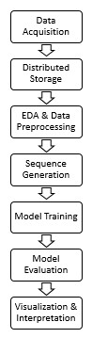
Fig. 7. Workflow of the proposed system

Model Training:
During this phase, four deep learning models namely: LSTM, GRU, BiLSTM and BiGRU are implemented using Adaptive Moment Estimation (Adam) optimizer and Mean Squared Error (MSE) as the loss function. The reason for choosing Adam optimizer is its adaptive learning rate mechanism, which combines the advantages of both Adaptive Gradient Algorithm (AdaGrad) and Root Mean Square Propagation (RMSProp). Moreover, it effectively tunes the learning rates for individual parameters, especially for time-series models like LSTM and GRU with numerous parameters and long-term dependencies; thus allowing for faster and more stable convergence.
During training, each model comprises of some recurrent layers with dropout for regularization, followed by a fully connected output layer to predict the next day’s closing price. With a total of 30 epochs and batch size of 32, both training and validation losses are monitored at each epoch, and the model parameters yielding the lowest loss are preserved to prevent overfitting. Finally, in order to determine the most optimal setup and parameters for each architecture, hyper-parameter tuning is carried out within the training loop for different hidden layer sizes, dropout rates, and number of layers. Table 1 lists the hyper-parameter values considered during tuning. The reason behind tuning a minimal set of hyper-parameters is to maintain computational efficiency and prevent overfitting. Moreover, due to the availability of a standard Virtual Machine (VM) of 6GB without GPU, using fewer hyper-parameters was a strategic decision for our work.

Model Evaluation:

The optimal model from each architecture is evaluated on both the training and test sets using RMSE, MAE, and R² metrics. For evaluation, predictions are inverse-transformed to the original price scale in order to ensure interpretability. Apart from these metrics, graphs are also plotted to compare actual and predicted values. This step helps in quantifying model accuracy and performance.

These metrics are chosen as they are commonly used to assess regression performance, especially when the predictions are continuous numerical values, such as in stock price prediction. Together, they provide a comprehensive view of the model's predictive accuracy, stability, and reliability.

A brief description of these metrics is given below:

MAE: The Mean absolute error represents the average of the absolute difference between the actual and predicted values in the dataset. It measures the average of the residuals in the dataset and is less sensitive to outliers compared to RMSE.

RMSE: It is the square root of Mean Squared error (MSE). MSE represents the average of the squared difference between the original and predicted values in

TABLE 1. Hyper-parameter Search

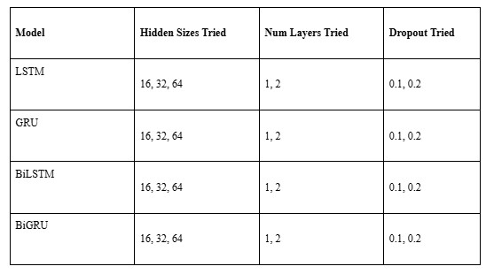

the data set and is a measure of the variance of the residuals. RMSE penalized larger errors more strongly, highlighting the model’s sensitivity to volatility and sensitivity to outliers.

R² (Coefficient of Determination): It represents the proportion of the variance in the dependent variable. It is used to assess the goodness of fit of a regression model and measures how well the model captures the overall variance and trend in the data.

Visualization:

In this phase, training and validation loss curves are plotted to assess the learning dynamics and convergence of the models. Additionally, actual versus predicted stock price plots are generated to visualize predictive performance. A summary table of metrics is also prepared to provide a clear comparison across architectures and highlight the model with the best performance. Overall, this approach facilitates an effective evaluation of model accuracy and illustrates the impact of architectural differences on predictive performance.

RESULTS AND DISCUSSION

The proposed deep learning models: LSTM, GRU, BiLSTM, and BiGRU are trained and validated using Apple stock prices from the yfinance (Yahoo Finance, 2025) dataset with an 80:20 training and testing data split. A portion of the training data (typically 10%) is used as a validation set to monitor learning dynamics and prevent overfitting. All models are trained for 30 epochs with a batch size of 32, time step of 30 and learning rate of 0.01. Hyper-parameter tuning is performed on hidden size, dropout rate and number of layers to identify the best configuration for each model. Their performance is assessed using RMSE, MAE, and R² on the training, validation, and test datasets.

Selected Hyper-parameters
Table 2 shows the best hyper-parameters selected for each model after tuning.

TABLE 2. Best Hyper-parameters for the models
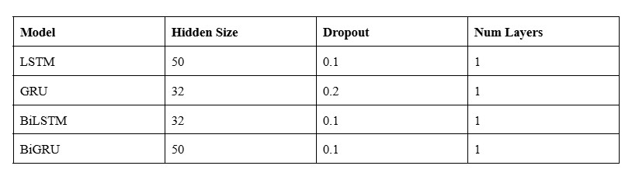

Training and Validation Performance:
This sub-section is going to discuss about training and validation loss curves that are plotted for each of the four models. The models were trained for 30 epochs each. Figures 8 and 9 show the training and validation loss curves for LSTM and GRU respectively. It can be seen from Figure 8 that for LSTM, training loss decreases steadily, while validation loss remains slightly higher initially. However, it starts converging after 7-8 epochs indicating good learning with a small generalization gap. Similarly, Figure 9 shows that in GRU, both training and validation losses drop and become stable comparatively faster than LSTM, showing that model converged reasonably quickly and better generalized on unseen data.
After LSTM and GRU, training and validation loss curves are plotted for BiLSTM, and BiGRU as shown in Figures 10 and 11. The curves indicate that although high initially, BiLSTM loss curves converge smoothly, with validation loss closely following training loss, reflecting stable learning and effective bidirectional temporal modeling. On the other hand, BiGRU exhibits an initial high value and slight delay in convergence, but it also achieves stable convergence after 6 epochs whereby the validation loss stays close to training loss, indicating good generalization and minimal overfitting.
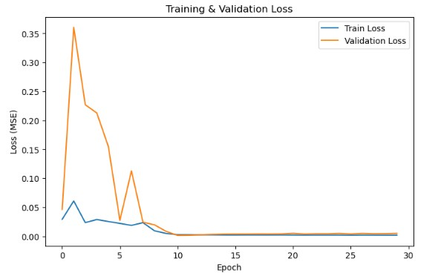
Fig 8. Training and validation loss for LSTM

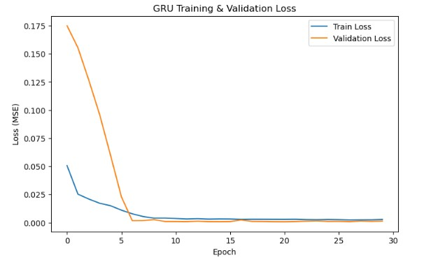
Fig 9. Training and validation loss for GRU

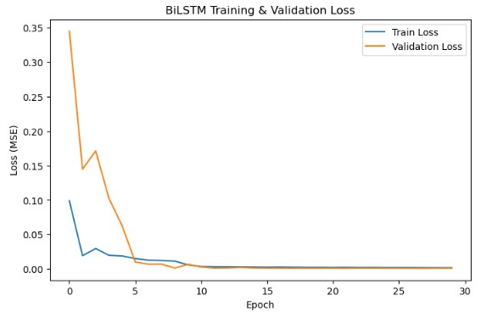
Fig 10. Training and validation loss for BiLSTM

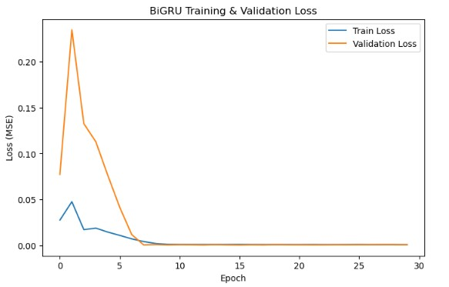
Fig 11. Training and validation loss for BiGRU

Overall, all models show decreasing training loss over epochs, with validation loss stabilizing after initial fluctuations. These curves also demonstrate better convergence of the bidirectional RNNs as compared to their unidirectional counterparts and effectively illustrate the learning dynamics during training

Quantitative Evaluation

The performance of all the four models was evaluated on both the training and testing sets, using metrics like RMSE, MAE, and R². Table 3 presents the performance comparison of the four models:

TABLE 3. Performance comparison of the models

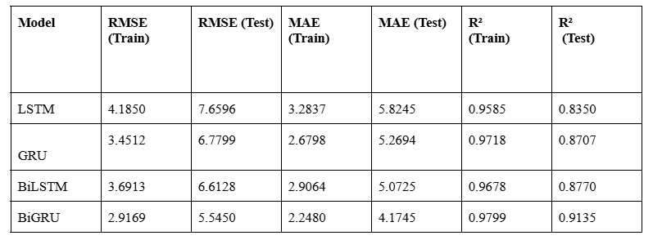

It can be seen from the table that all four recurrent neural network models: LSTM, GRU, BiLSTM, and BiGRU demonstrated strong predictive performance on the stock closing price dataset. The LSTM achieves a good fit to the training data and generalizes reasonably well to the test set, though there is a modest increase in error. The GRU slightly outperforms LSTM on test data (R² = 0.871), likely due to its more parameter-efficient gating mechanism, showing robust generalization with minimal overfitting.

The BiLSTM, leveraging bidirectional context, further improves predictive accuracy (R² = 0.877 on test data), demonstrating that capturing both past and future temporal dependencies enhances performance. Finally, the BiGRU achieves the best overall results, with the lowest prediction errors (Test RMSE = 5.55) and highest explanatory power (R² = 0.914), effectively learning complex temporal patterns while maintaining excellent generalization.

Across all models, the gap between training and test performance remains moderate, indicating good generalization without overfitting. Overall, the results highlight that bidirectional models outperform their unidirectional counterparts on the test set and BiGRU model achieves the best overall performance with the highest R² for time-series forecasting. This is because these models incorporate information from both past and future observations, making them highly suitable for financial trend prediction.

Visual Analysis of Actual vs Predicted Values

To further assess model performance, predicted vs. actual stock prices were plotted for each model. Figures 12 and 13 show the actual versus predicted price plots for GRU and LSTM. It can be inferred from the plots of Figure 12 that the LSTM captures the overall trend of the time series but with some deviation during volatile periods, indicating minor under-fitting on unseen data. Similarly, Figure 13 shows that the GRU predictions closely follow the actual values, reflecting improved temporal learning and smoother generalization compared to the LSTM.

Following this, Figures 14 and 15 show the actual versus predicted price plots for BiGRU and BiLSTM. These figures show that the BiLSTM model provides a tighter fit to the actual series, demonstrating its ability to learn from both past and future temporal dependencies, resulting in smoother and
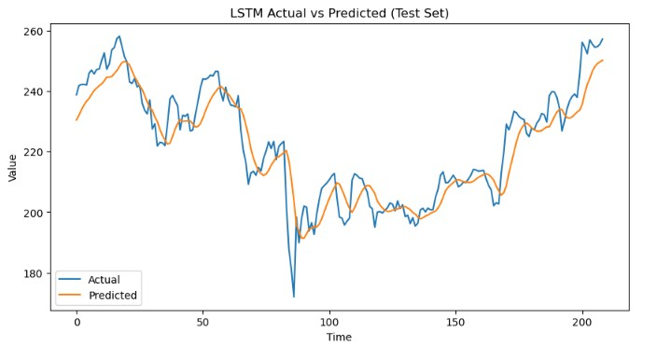

Fig 12. Predicted vs actual values for LSTM

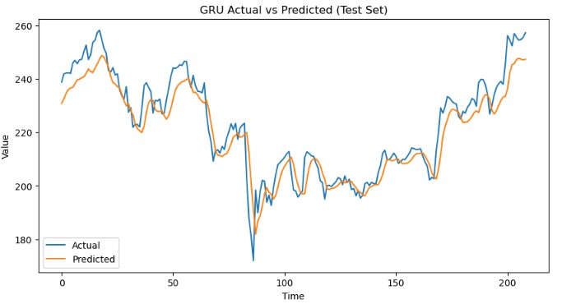
Fig 13. Predicted vs actual values for GRU

more accurate forecasts. However, the BiGRU model exhibits the best alignment between actual and predicted values, with minimal lag and error, highlighting its superior capability in capturing bidirectional dependencies and complex time-series patterns.

Overall, it can be seen that BiGRU predictions closely follow the actual stock prices giving the best performance, while other models show slightly higher deviations, particularly in periods of high volatility.

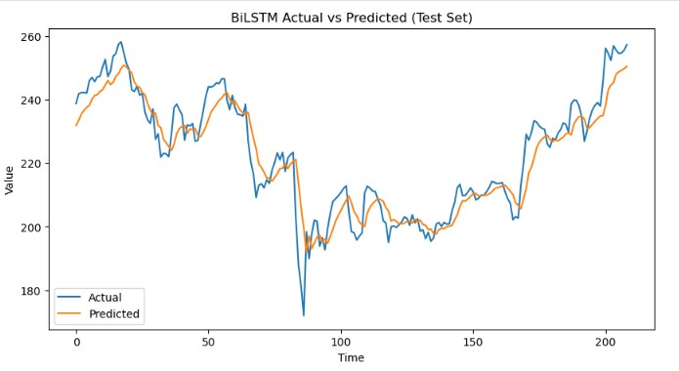

Fig 14. Predicted vs actual values for BiLSTM

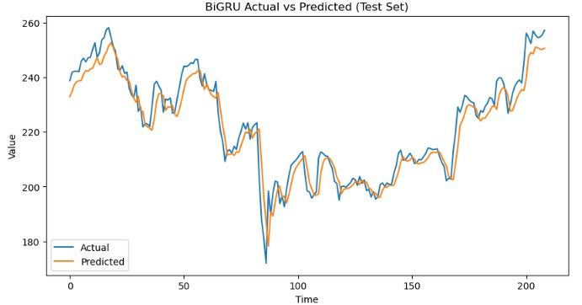
Fig 15. Predicted vs actual values for BiGRU

CONCLUSION

This research compares deep learning models like LSTM, GRU, BiLSTM and BiGRU for stock price prediction, in the context of integrating big-data preprocessing with neural network modeling, and strives to determine the best architecture that can generalize to unseen data under controlled hyper-parameter tuning. By training all models for 30 epochs and window size of 30 and hyper-parameter tuning over hidden size, dropout, and layer count, we find that while all models learn the temporal patterns present in the Apple stock dataset, BiGRU stands out in terms of stock price prediction performance with lowest RMSE and highest R² values. This confirms that bidirectional models provide a substantial advantage for modeling financial time series as compared to the unidirectional models, under the proposed framework. Moreover, our approach also addresses prior research gaps: many forecasting studies omit the use of big data frameworks in preprocessing and typically rely solely on Pandas while others neglect rigorous hyper-parameter tuning or fail to compare bidirectional architectures side by side. Thus, by combining big data technologies like Hadoop and Pyspark with deep learning models, we demonstrate a practical pipeline suited for large-scale time series forecasting. In short, our results show that the proposed architecture choice and careful tuning are more consequential than simply making models deeper, and that a robust big-data and deep learning integration is both feasible and beneficial for stock prediction tasks.

With regards to future work, hybrid and ensemble architectures that combine recurrent models with attention or convolutional modules; can be explored. For instance, integrating a CNN-BiGRU with a temporal attention layer can capture both local patterns and long-range dependencies more effectively. Additionally, broadening the hyper-parameter search (e.g. testing varied learning rates, more epochs) could uncover even better model configurations leading to improved accuracy, than those examined here. Beyond architecture, further exploration into the adoption of rolling-window or walk-forward validation could be done for stock data in order to test the stability of models across shifting market regimes, instead of relying on a single train-test split. Finally, incorporating exogenous features such as macroeconomic indicators, sentiment analysis from news or social media, or technical indicators could provide richer context for price prediction and help improve generalization in volatile periods. This could ultimately allow the models to better capture intricate market dynamics and offer even more precise predictions, leading to valuable tools for financial analysts and investors in making informed and strategic decisions.

References

- Dong, H. (2022) ‘Stock Price Prediction Using ARIMA and LSTM’, 6th Annual International Conference on Data Science and Business Analytics (ICDSBA). Changsha, China, 2022. New York: IEEE, pp. 195–201. doi: 10.1109/ICDSBA57203.2022.00055.
- Čatloch, D., Chovancová, E. and Matašová, S. (2025) ‘Comparison of Different Machine Learning Algorithms for Stock Price Prediction’, IEEE 23rd World Symposium on Applied Machine Intelligence and Informatics (SAMI). Stará Lesná, Slovakia, 2025. New York: IEEE, pp. 483–488. doi: 10.1109/SAMI63904.2025.10883315.
- Yahoo Finance (2025) Apple Inc. (AAPL) historical stock data, accessed via yfinance Python library, Available at: https://finance.yahoo.com/quote/AAPL/history (Accessed: 6 October 2025).
- Apache Software Foundation (2025) Apache Hadoop. Available at: https://hadoop.apache.org/ (Accessed: October 2025)
- Apache Software Foundation (2025) PySpark 4.0.1 Python API Documentation. Available at: https://spark.apache.org/docs/latest/api/python/index.html (Accessed: 3 October 2025).
- Tang, H. (2021) ‘Stock Prices Prediction Based on ARMA Model’, 2021 International Conference on Computer, Blockchain and Financial Development (CBFD), Nanjing, China, pp. i–iv. doi: 10.1109/CBFD52659.2021.00046.
- Sharma,R., Sharma, R. and Hariharan, S. (2024) ‘Stock Price Prediction Using ARIMA: A Study on AAPL, MSFT, NFLX, and GOOGL Stocks’, 2024 International Conference on Computational Intelligence and Computing Applications (ICCICA), Samalkha, India, pp. 47–50. doi: 10.1109/ICCICA60014.2024.10584587.
- Kareem, S., Hamad, Z. J. and Askar, S. (2021) ‘An evaluation of CNN and ANN in prediction weather forecasting: A review’, Sustainable Engineering and Innovation, 3(2), pp. 148–159. doi: 10.37868/sei.v3i2.id146.
- Reddy, K. R., Kumar, B. T., Ganesh, V. R., Swetha, P. and Sarangi, P. K. (2022) ‘Stock Market Prediction Using Recurrent Neural Network’, 2022 IEEE International Conference on Current Development in Engineering and Technology (CCET), Bhopal, India, pp. 1–4. doi: 10.1109/CCET56606.2022.10080154.
- Liu, Y. (2022) ‘Stock Prediction Using LSTM and GRU’, 2022 6th Annual International Conference on Data Science and Business Analytics (ICDSBA), Changsha, China, pp. 206–211. doi: 10.1109/ICDSBA57203.2022.00054.
- Rathna, K. and Devi, S. V. S. (2025) ‘RNN, GRU, and LSTM Model Analysis for AI-Powered Indian Stock Market Index Forecasting’, 2025 International Conference on Visual Analytics and Data Visualization (ICVADV), Tirunelveli, India, pp. 1517–1523. doi: 10.1109/ICVADV63329.2025.10960873.
- Sharma, A., Chauhan Gonder, S. S. and Garg, P. (2025) ‘Leveraging Deep Learning for Predictive Analysis of S&P BSE SME IPO Index Close Price’, 2025 2nd International Conference on Research Methodologies in Knowledge Management, Artificial Intelligence and Telecommunication Engineering (RMKMATE), Chennai, India, pp. 1–6. doi: 10.1109/RMKMATE64874.2025.11042483.
- Tripathy, N., Parida, S., Kumar, S., Nayak, S. and Tripathy, N. (2023) ‘Forecasting Stock Market Indices Using Gated Recurrent Unit (GRU) Based Ensemble Models: LSTM-GRU’, International Journal of Computer and Communication Technology, 9, pp. —. doi: 10.47893/IJCCT.2023.1443.
- Qi, C., Ren, J. and Su, J. (2023) ‘GRU Neural Network Based on CEEMDAN–Wavelet for Stock Price Prediction’, Applied Sciences, 13(7104). doi: 10.3390/app13127104.
- Hemajothi, S., Babu, S. S., Prathiksha, V., B, S., E, S. and K, S. (2024) ‘Prediction of Stock Price Model through the Implementation of Hybrid BiLSTM-GRU’, 2024 International Conference on Recent Advances in Electrical, Electronics, Ubiquitous Communication, and Computational Intelligence (RAEEUCCI), Chennai, India, pp. 1–6. doi: 10.1109/RAEEUCCI61380.2024.10547920.
- Shaikh, Z. and Ramadass, S. (2024) ‘Unveiling deep learning powers: LSTM, BiLSTM, GRU, BiGRU, RNN comparison’, Indonesian Journal of Electrical Engineering and Computer Science, 35, pp. 263–273. doi: 10.11591/ijeecs.v35.i1.pp263-273.
- Kumari, K., Das, S., Bhowmick, A., Saha, A., Puja, A. B. and Karmakar, K. (2024) ‘Stock Price Prediction Using Machine Learning’, 2024 International Conference on Big Data Analytics in Bioinformatics (DABCon), Kolkata, India, pp. 1–6. doi: 10.1109/DABCon63472.2024.10919355.
- Inoubli, W., Aridhi, S., Mezni, H., Maddouri, M. and Mephu Nguifo, E. (2018) ‘An experimental survey on big data frameworks’, Future Generation Computer Systems, 86, pp. 546–564. doi: 10.1016/j.future.2018.04.032.
- Liu, Y. (2024) ‘The Investigation of the Application of Apache Spark in Stock Analysis’, Proceedings of the 1st International Conference on Engineering Management, Information Technology and Intelligence (EMITI 2024), pp. 501–505. doi: 10.5220/0012957600004508.
- Indirman, M. D., Wiriasto, G. and Irfan Akbar, L. A. (2023) ‘Distributed Machine Learning using HDFS and Apache Spark for Big Data Challenges’, E3S Web of Conferences, 465. doi: 10.1051/e3sconf/202346502058.
- Dubey, M. and Kumari, U. (2025) ‘Use of big data analytics on system comprising stock market research and predictions’, IET Conference Proceedings, 2024, pp. 129–133. doi: 10.1049/icp.2025.0782.

